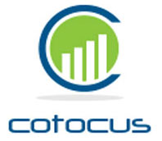
Cotocus Private Ltd.
Digital Transformation Enablers

DOOR#2, #46, 2nd Cross,
Muniswara Layout, Ayappa Nagar,
Devesandra Main Road, K R PURAM,
Bangalore - 560036
www.Cotocus.com

Date: - 30th-Jun 2022

Experience latter / Certificate

To,

Whomsoever it May Concern,

This is to certify that Mr. Dharmendra Kumar, was working as a “Junior Software Engineer” in our organization as a full employee from July, 2019 to Jun, 2022 in Bokaro Steel City, Jharkhand branch. During that time he developed different Software and maintained our various websites. We found him honest, dedicated, hardworking and well-behaved during his working period with us.

We wish him good luck and success in his all future endeavors.

For COTOCUS PRIVATE LIMITED

Authorized Signatory:-
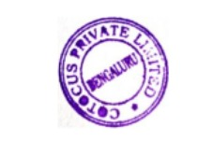
Date of signing the declaration:-

